1. Revising the Select Query I
=======================
Query all columns for all American cities in the CITY table with populations larger than 100000. The CountryCode for America is USA.
The CITY table is described as follows:
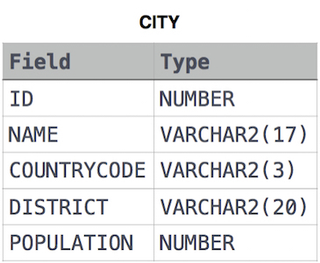

Answer:
======
select *
from CITY
where POPULATION > 100000 and COUNTRYCODE = 'USA'

